ASSIGNMENT-1

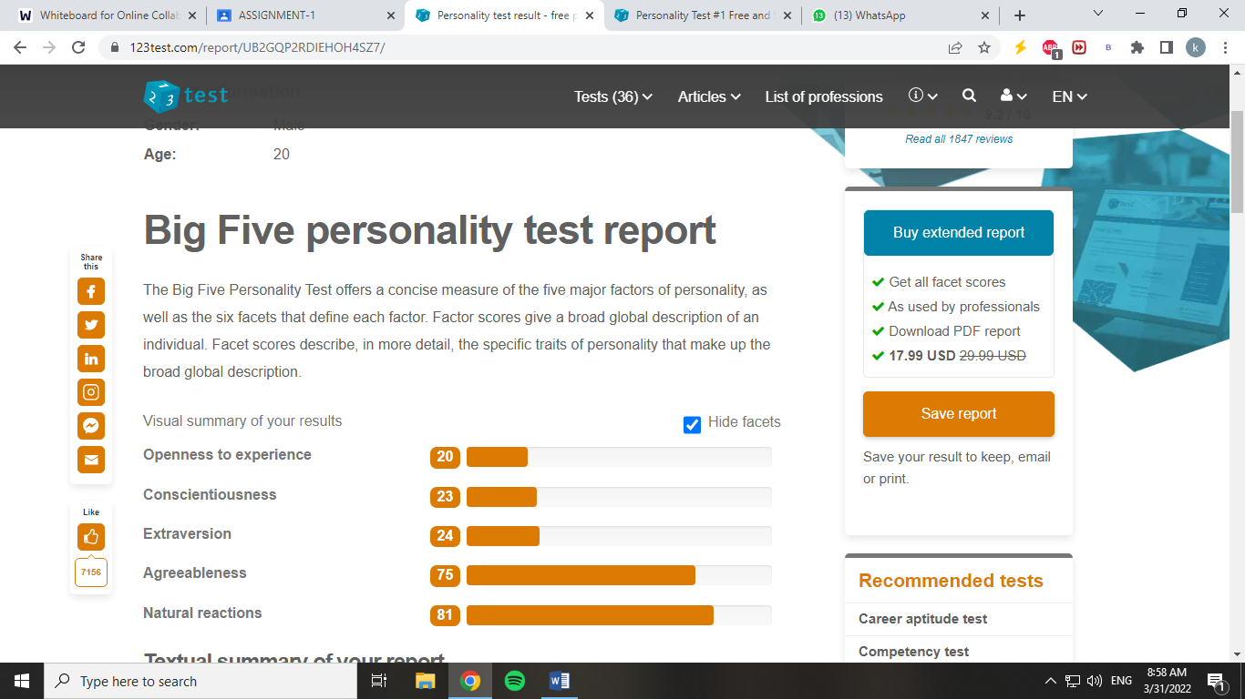

**Openness to experience:** I might not be open to experiences because I like to keep myself reserved. I am afraid to experience new things.

**Example:** I often lack creativity while thinking of project ideas however I am easily able to think logically while problem solving part of my project.

##### **Conscientiousness:** I am often spontaneous and disorganized.

**Example:** I am less bothered to please others and often do what is flexible for me. I often leave my bedroom messy after I wake up.

##### **Extraversion:** I am an introverted kid who’s quiet and prefer working alone.

**Example:** I enjoy studying alone and prefer self-studying rather lectures in my class or group studying.

##### **Agreeableness:** I am usually warm, friendly, and tactful. I generally have an optimistic view of human nature and get along well with others.

**Example:** I am a person who loves to help others if they are cooperative. I love people to help them with their projects and assignments.

##### **Natural reactions:** I have less emotional stability however I might not able to express my emotions but I am never emotionally stable.

**Example:** I am really anxious and experience social anxiety around people. I never communicate my words properly. Often while social interactions I am able to communicate my message properly and people wouldn’t understand and often assume random things about me.